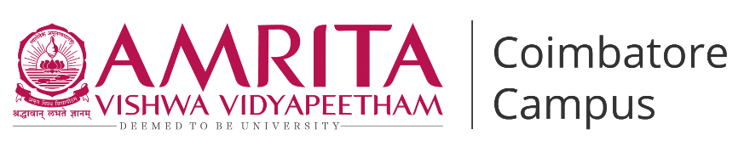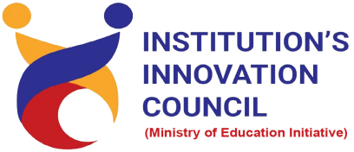

**Live-in-Labs® : Field Visit to Anna Nagar , Ramanathapuram**

**Activity Category :** Self – Driven Activities

**Event Title :** Live-in-Labs : Field Visit

**Dates :** Live-in-Labs 1 : 23.12.24 to 28.12.24

Live-in-Labs 2 : 24.01.25 to 03.05.25

**Occasion/Theme :** Experiential Learning

**Organized by :** Live-in-Labs, Amrita Vishwa Vidyapeetham



**Overview**

The Live-in-Labs® project in ***Anna Nagar, Ramanathapuram****, Tamil Nadu* was carried out by a team of Amrita students and international students under the mentorship of ***Dr. Anu G Kumar***. The focus of the visit was to address the challenge of women’s livelihood insecurity, where married women contributed only ~₹2,000 per month to household income, leaving an average family deficit of ₹3,735, compounded by limited vocational skills (only 12% trained) and low participation in skilled employment (<8%) through innovative, sustainable, and community-driven solutions.

The team interacted with villagers, conducted surveys, and studied the socio-economic conditions to identify root causes of the problem. Based on this, solutions such as [“Establishing SHG-led production and distribution units for Saukhyam reusable sanitary pads to generate sustainable livelihoods and improve menstrual health*”]* and [“Developing AI-enabled mobile solutions to help rural women track, manage, and optimize microfinance loans, thereby breaking recurring debt cycles*”]* were proposed. These interventions combine scientific knowledge with frugal innovation, making them both cost-effective and scalable.

The visit provided the team with hands-on exposure to applying classroom concepts in real-world contexts. Students gained valuable knowledge on design thinking, grassroots innovation, and community engagement. The collaboration between Amrita and international students enriched the process with diverse perspectives, ensuring that the solutions were both technically sound and socially acceptable.

Overall, the project demonstrated how grassroots challenges can be transformed into opportunities for innovation and entrepreneurship. The solutions identified have the potential for further prototyping, incubation, and replication in other rural contexts, aligning with the vision of IIC to foster innovation-driven impact.

**Planning & Execution**

The project was planned in advance based on the schedule prepared and submitted during the Live-in-Labs® workshop. The schedule served as a roadmap, outlining each stage of the work from preliminary study to field immersion and final reporting. In the initial phase, the team conducted a background study of the village and gathered secondary data to understand the broader context of the problem. This was followed by structured planning of surveys, community interactions, and technical assessments, all aligned with the timelines agreed upon.

**Day wise Schedule**

Live-in-Labs 1:

* **Day 0 (22/12/24):** Travelled to the village, met coordinator and leaders (Pradhan, Anganwadi, Asha), and settled at the stay.
* **Day 1 (23/12/24):** Conducted transect walk 1, seasonal calendar activity, and Anganwadi visit.
* **Day 2 (24/12/24):** Conducted transect walk 2, household surveys, PHC visit, SHG/NGO interactions, and unstructured interviews.
* **Day 3 (25/12/24):** Continued household surveys, resource mapping, AEIOU framework, brainstorming, and scenario building.
* **Day 4 (26/12/24):** Conducted structured interviews, prepared personas, scenarios, and Venn diagrams.
* **Day 5 (27/12/24):** Organized community brainstorming session, Govt school visit, and focused group discussions.
* **Day 6 (28/12/24):** Held brainstorming session, created problem tree, and mentor-team discussions.
* **Day 7 (29/12/24):** Consolidated insights with refined problem tree, persona/scenario drafting, Venn diagram updates, and final documentation.

Live-in-Labs 2 :

* **Day 0 (24/04/25 – Thursday):** Travel to the village, awareness session with Saukhyam team & Anju Madam, meetings with Dr. Joseph, major women stakeholders, and Swamini Amma.
* **Day 1 (25/04/25 – Friday):** Meetings with Arumugam, Saukhyam team brainstorming, Anna Nagar village visit, Ekal Vidyalaya teachers, 25 nurses workshop at Rajan hospital, and village visit.
* **Day 2 (26/04/25 – Saturday**): Inauguration of Saukhyam pad unit, Field visit of Valuthulur village,planning for awareness sessions.
* **Day 3 (27/04/25 – Sunday):** Meetings with District Collector of Ramnad, further field visits to nearby communities with Saukhyam team and recruits.
* **Day 4 (28/04/25 – Monday):** Visits to Rameshwaram town – medical retailers and marketing expansion activities.
* **Day 5 (29/04/25 – Tuesday):** Visits to Madurai, Paramakudi, Sayalkudi, SHG – focused on marketing and awareness.
* **Day 6 (01/05/25 – Thursday):** Meeting Mr. Arumugam (Resource person for SHG based enterprises), co-design report drafting, proof of concept documentation, and paper writing.
* **Day 7 (02/05/25 – Friday):** Feedback collection from recruits, meeting with Swamini Amma on expansion, Rameswaram visit, and thanksgiving with villagers.

**Impact & Outcomes**

* **Innovation :** The project demonstrated how grassroots challenges can inspire innovative, frugal solutions. By integrating scientific concepts with local knowledge, the team co-designed **production and distribution models for Saukhyam reusable pads**, leveraging banana fibre as a sustainable raw material. These interventions were conceived to be low-cost, adaptable across different village contexts, and scalable through government-supported platforms like Mahalir Thittam (Mathi). This process highlighted the power of student-led innovation to transform a pressing social challenge—women’s financial dependency and menstrual health insecurity—into practical, impactful models of rural development that integrate livelihood creation, environmental stewardship, and women’s empowerment.
* **Design Thinking :** The outcomes of the project were achieved by following a design-thinking approach. Students empathized with villagers through surveys and discussions, defined the root problems, ideated possible solutions, and tested their feasibility with the community. This systematic method ensured that the solutions were not only technically feasible but also socially acceptable and context-specific.
* **Entrepreneurship Potential :** Several proposed solutions have the potential to evolve into entrepreneurial models or community-led startups. For instance, the SHG-driven production and distribution of Saukhyam reusable sanitary pads can be nurtured into a sustainable rural enterprise that not only generates consistent income for women but also fosters dignity, ownership, and confidence among them. Beyond addressing menstrual health and environmental concerns, such an enterprise strengthens social capital, builds leadership within Self-Help Groups, and creates a replicable blueprint for other villages. This holistic approach aligns strongly with IIC’s vision of nurturing student entrepreneurship that transcends profit-making to deliver scalable, socially impactful ventures.
* **Sustainability :** The solutions emphasized long-term sustainability by making use of locally available resources and building capacity within the community. As a result, the interventions can be maintained by villagers themselves without heavy dependence on external support. This ensures that the outcomes continue to create impact even after the project phase ends.
* **Societal Impact :** The immediate impact of the project was raising awareness among community members about alternative and innovative practices. In the long run, the solutions are expected to improve living standards, reduce resource-related hardships, and strengthen the resilience of the village. The project also encouraged local youth to view innovation as a tool for solving their own challenges.
* **Collaboration and Knowledge Sharing :** A significant outcome of the project was the knowledge exchange that took place between Amrita students, international peers, and the local community. This cross-cultural collaboration enriched the learning experience, allowed multiple perspectives to be considered, and helped design solutions that were technically sound, socially relevant, and globally informed.

**Participation**

1. **Student Members** :

· **ABHINAYA BHARATH - CB.EN.U4CHE22008**

· **ASWIN RAM KUMAR GANNINA - CB.EN.U4CSE22305**

· **CHERAN K - CB.EN.U4EEE22009**

· **DEO VAIBHAV - CB.EN.U4EEE23006**

· **Jasmitha Gutha - CB.EN.U4CSE22225**

· **K PREM CHAND - CB.EN.U4ELC23024**

· **Mrs Parijat - AM.ID.R4IDS23034**

· **RITHANYA - CB.EN.U4ECE22048**

· **SAI CHETAN A V - CB.EN.U4CSE22151**

· **VISRAM ANAND - CB.EN.U4CHE23057**

**Contribution to SDGs**

The project contributes to several United Nations Sustainable Development Goals (SDGs):

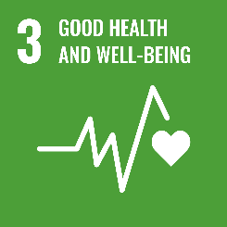

By addressing **menstrual health awareness and access to safe, reusable sanitary products,** the project improves health outcomes for the community.

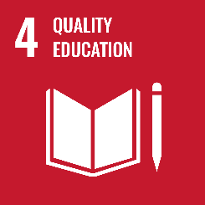

Knowledge sharing, awareness programs, and cross-cultural learning enhanced educational opportunities for both villagers and students.

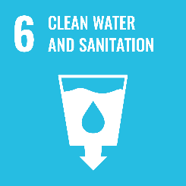

Proposed solutions such as menstrual hygiene education, safe pad maintenance practices, and responsible disposal mechanisms directly improve access to safe water and sanitation facilities.

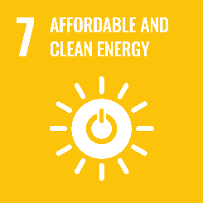

Interventions like training women in energy-efficient stitching practices and exploring solar-powered stitching units for rural production centres, promote clean and sustainable energy alternatives.

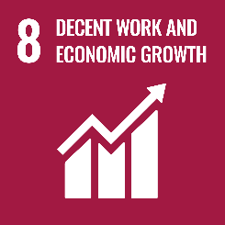

Entrepreneurial potential of the solutions encourages community-based enterprises and livelihood opportunities.

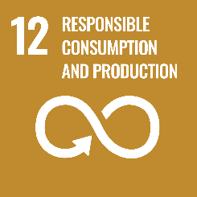

Responsible Consumption and The solutions emphasize frugal innovation, waste reduction, and sustainable use of resources.

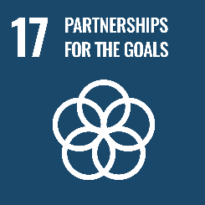

Collaboration between Amrita students, international peers, and the village community reflects strong global partnerships for sustainable development.

**Images:**

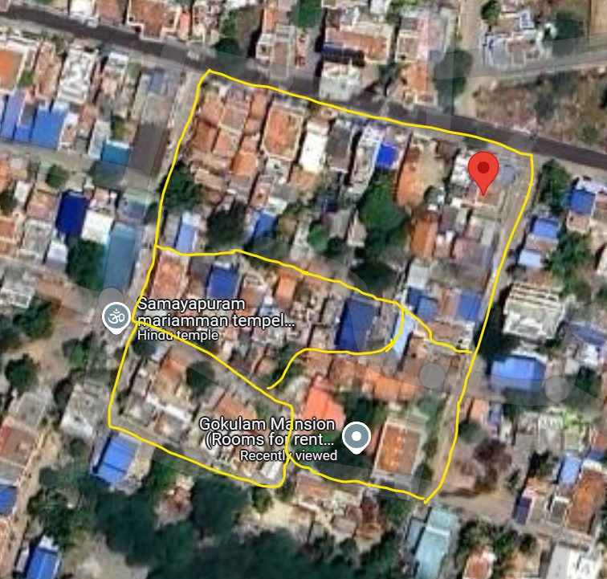

Fig.1 Satellite view of the village

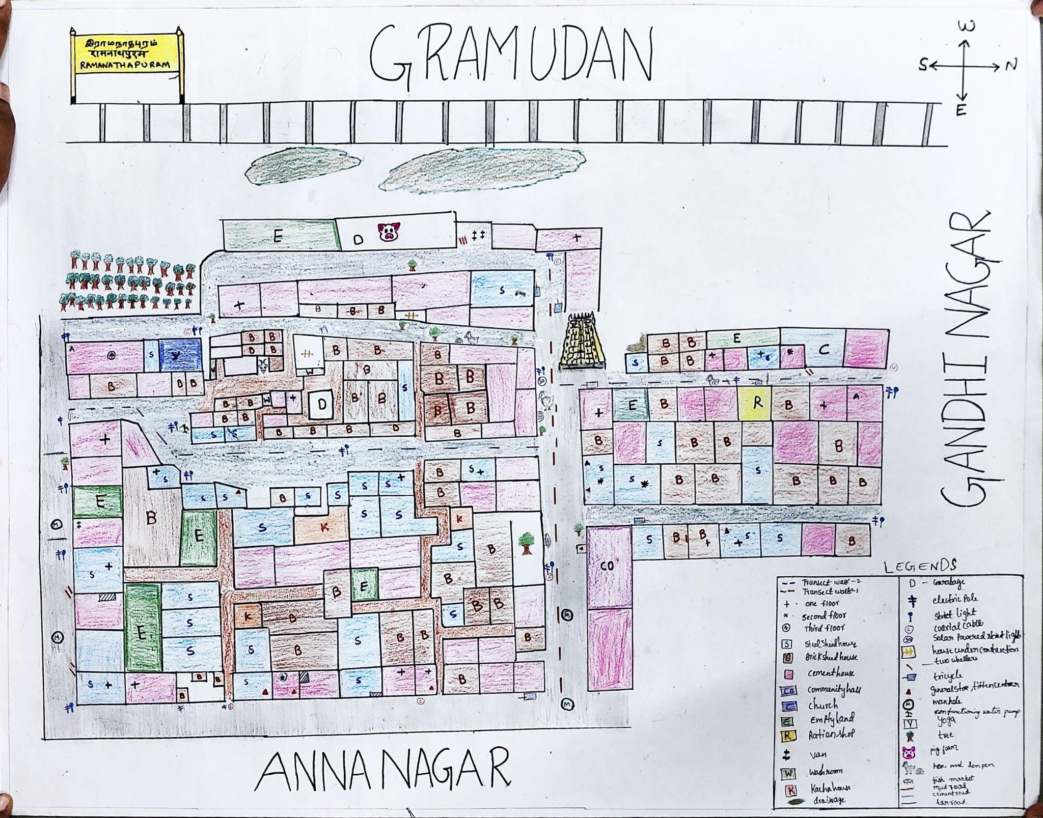

Fig.2 Resource map of the village

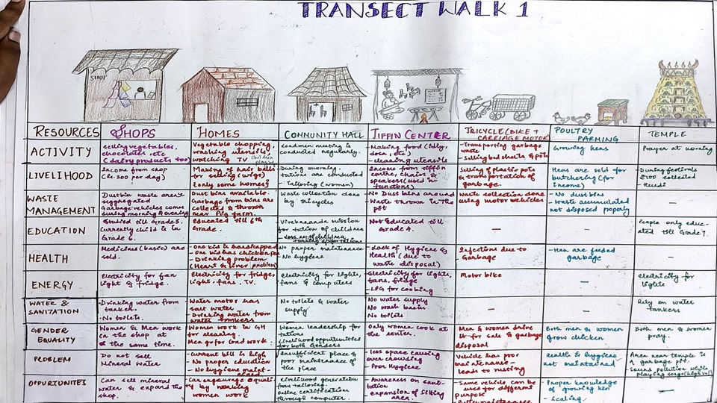

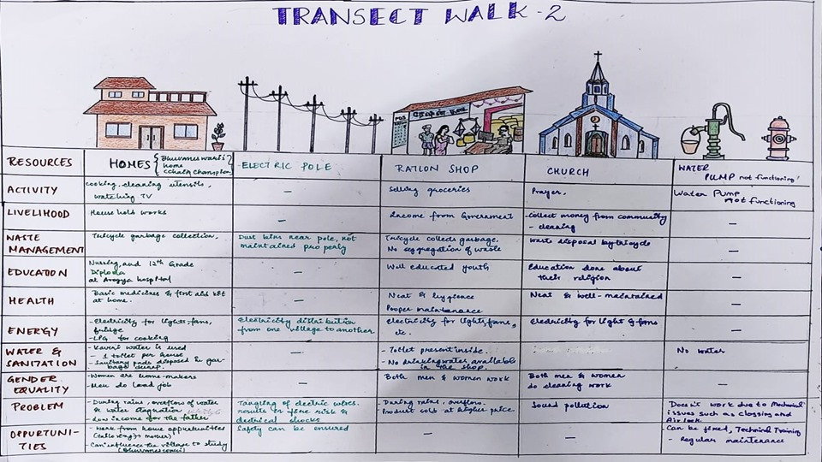

Fig.3,4 Transect walks 1 and 2

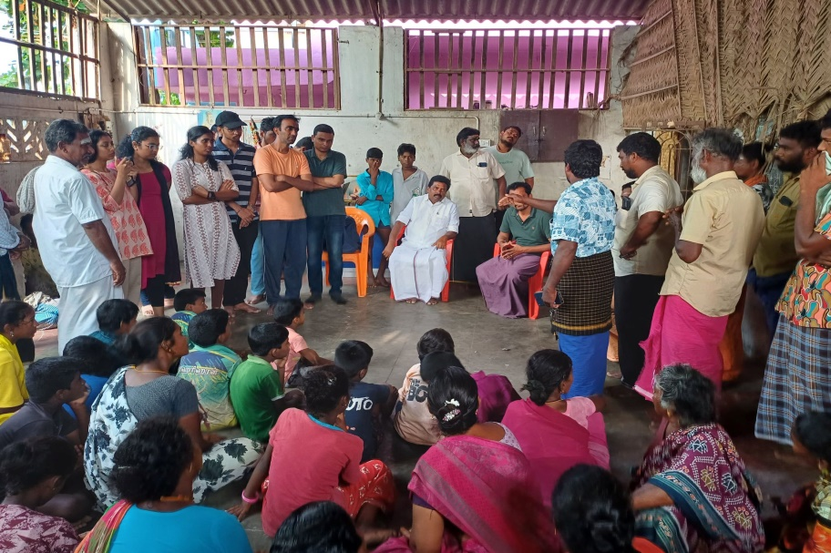

Fig.5 Brain storming session with Municipal chairperson and villagers

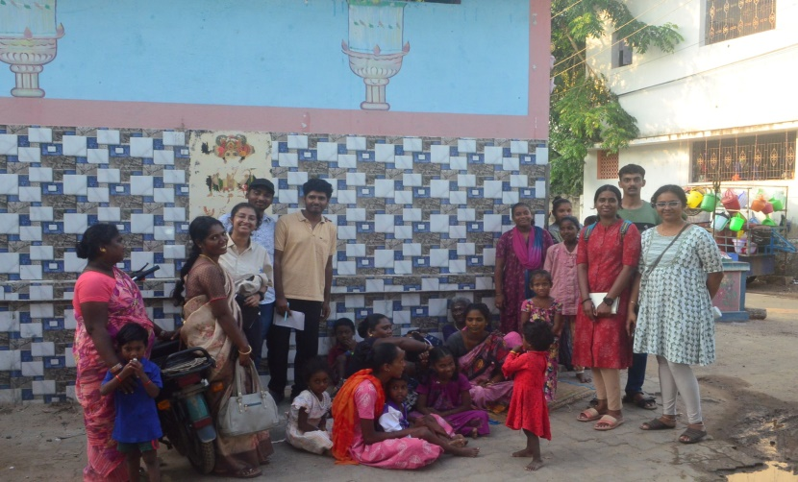

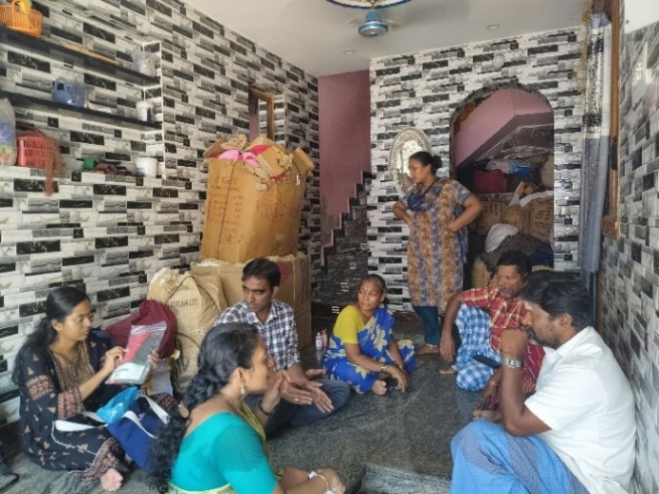

Fig.6, 7 Session with Village head and Village coordinator

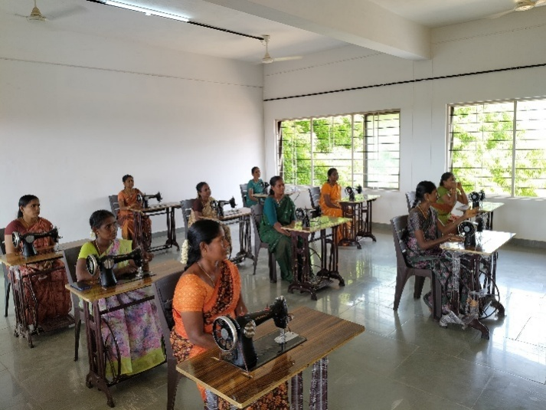

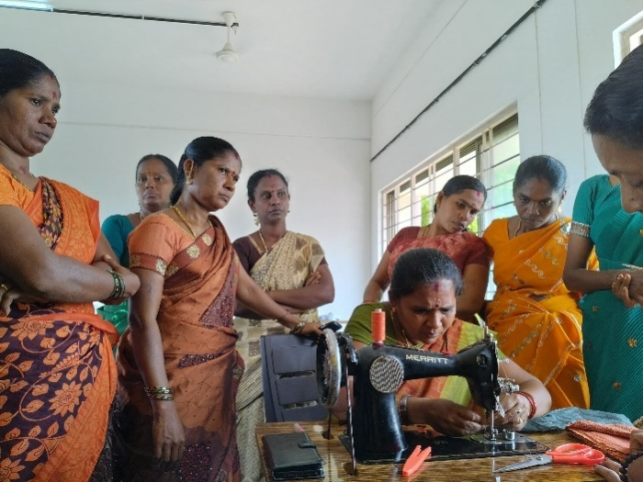

Fig. 8, 9 Training-cum-Production Centre was established and at Amrita Vidyalayam

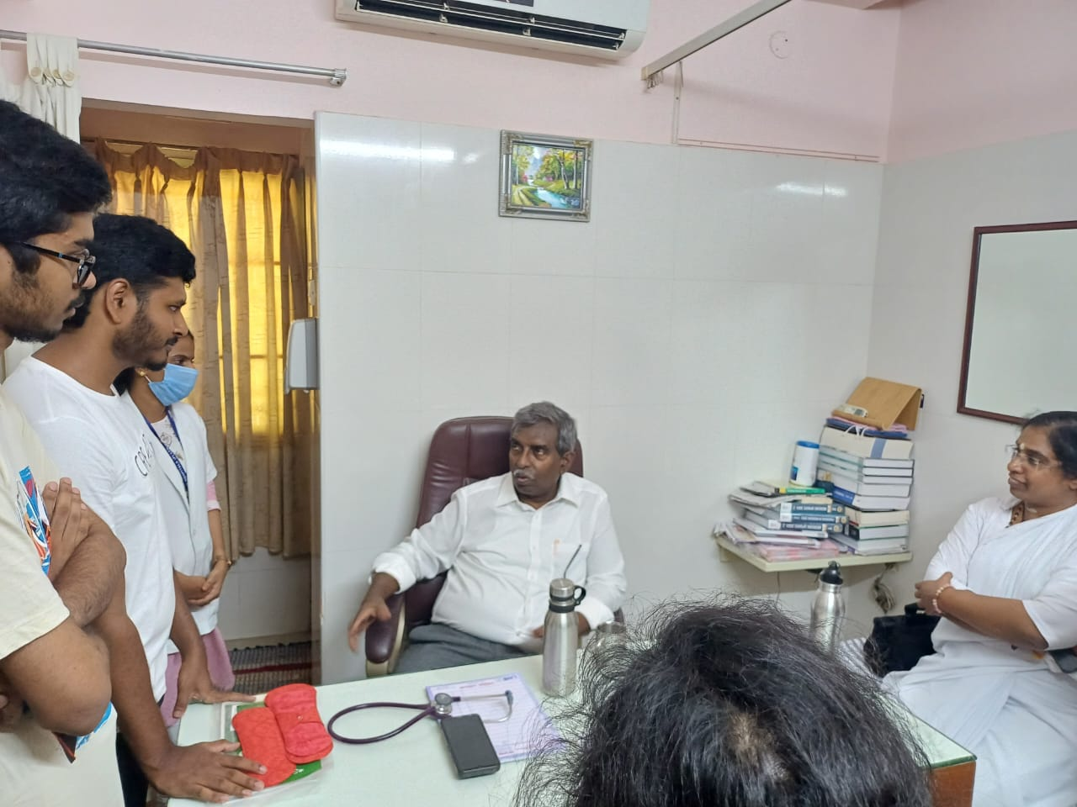

Fig. 10 Interacting with Dr. Rajan at Rajans Hospitals

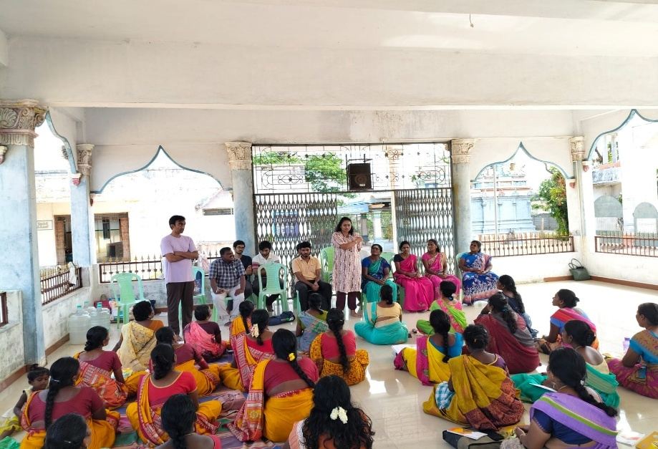

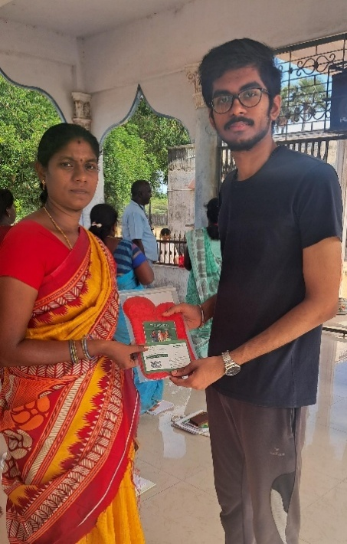

Fig. 11, 12 Meeting and marketing with Ekal Vidyalaya Teachers

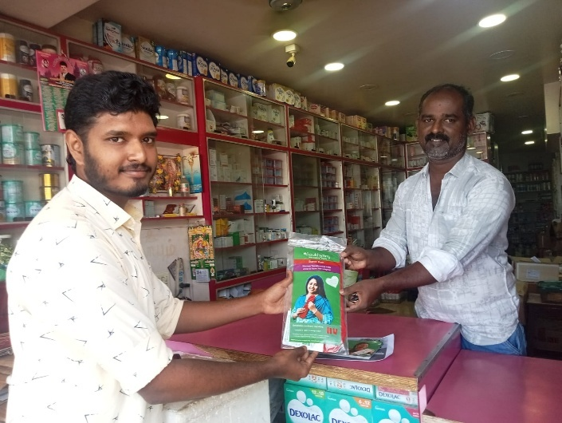

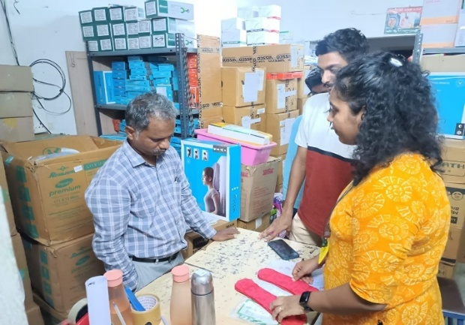

Fig. 13, 14 Team Gram Udan meetings the local wholesalers and medical shops

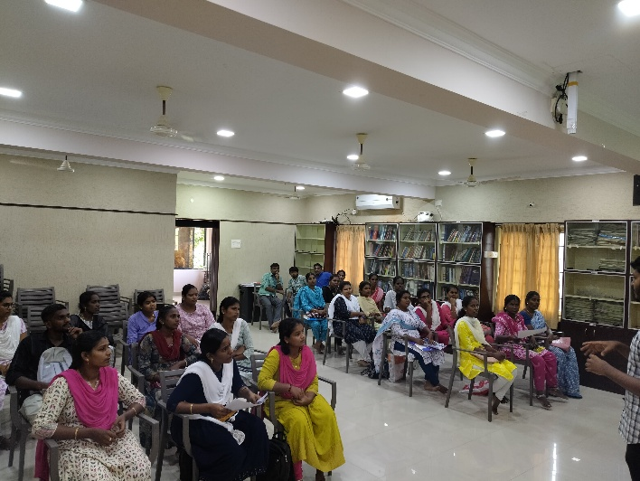

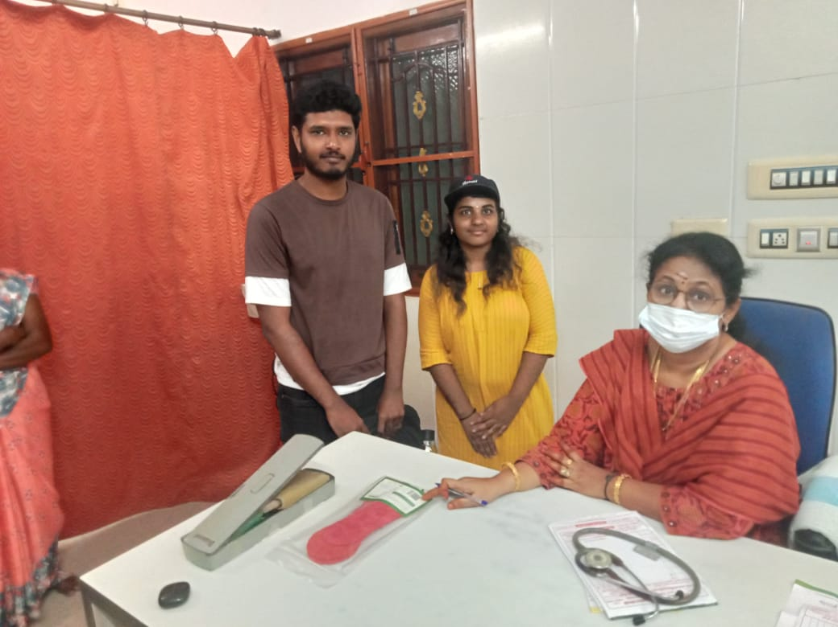

Fig. 15, 16 Team Gram Udan meeting gynaecologist and nurses

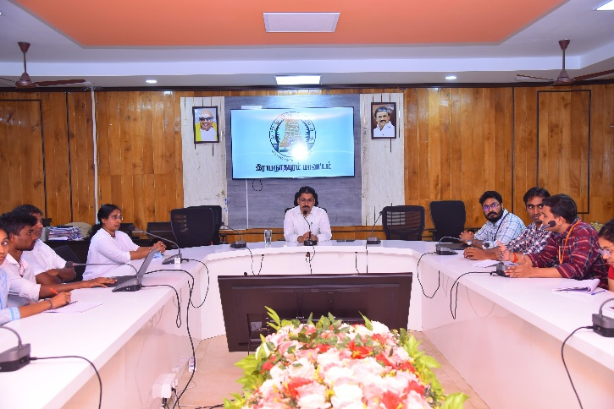

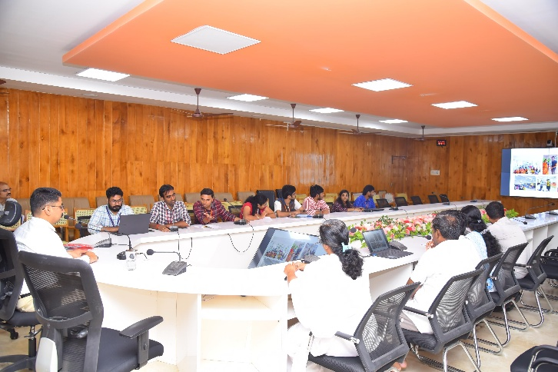

Fig. 17 Discussion with The District Collector of Ramnad

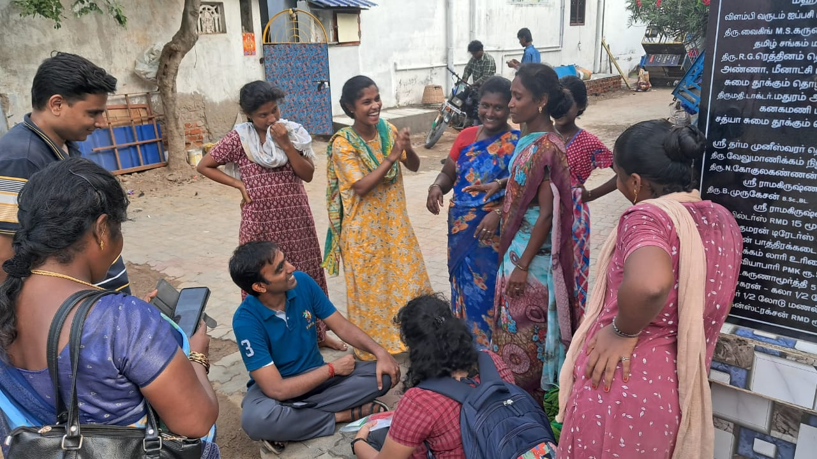

Fig. 18 Co-design with the villagers for marketing

